Northeast Junior Squad (NEJS) Report 2025-26
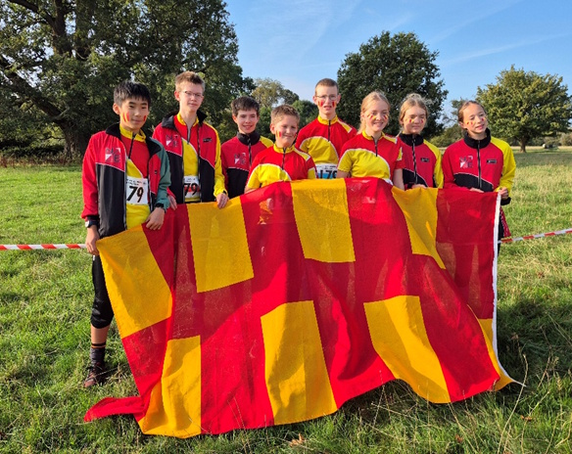
Membership:
Our total number of members remains at 13 as follows:
M/W18 | 3 | BM, WR, IS
M/W17
M/W16 | 1 | TP
M/W15 | 3 | ND, RS, JL
M/W14 | 3 | AH, OP, WB
M/W13 | 0
M/W12 | 3 | FD, LS, PR
M/W11 | 0

We have not lost or gained any members in the 25/26 year group, and we have 4 juniors keen to join when they are old enough. We did consider creating a squad admissions policy like the other squads do (selected based on ability/standards etc), but in reality we don’t have the numbers to necessitate this. In our opinion having an ‘open to all’ squad makes us very inclusive and we are as focused on the long-term commitment to the sport, based on friendships built and memories shared, as well as the fitness gained, than we are on winning medals. The only stipulation we have it that our juniors must be 11 years old (and ideally in year 7 if we are taking them away).
Coaching qualifications:
- Rebecca, Julian and Jeanette all gained their Level 2 Orienteering coaching award in May, following over 12 months of hard work and assessments!
- Lewis Balfour from NN (one of our juniors Dad) is looking to enrol on the same course so he should be able to assist us in the coming year.
- All coaches have completed the relevant safeguarding and first aid training.
Training:
- November – JROS Hawkshead weekend
William R attended the annual M/W16’s training weekend held at Hawkshead. Unfortunately Isla and Julian were unable to attend due to catching Covid, so the EMJOS took over responsibility of WR for the weekend (with parental consent).
- December – Christmas Training Day at Hartlepool
We held a fun Christmas training day at Summerhill Country Park, where siblings and parents were invited to join in. Certificates were awarded to all our juniors congratulating them on their performances and commitment to the squad. It was a really fun day for all.
- March – Training weekend at Grizedale Woods (Lakes)
In preparation for the JK 2026, we held a training weekend in the Lakes, focusing on reading and understanding complex contour detail (including hill tops and pits), before staying overnight at Finsthwaite Village Hall. The following day the juniors competed at the LOC regional event at Witherslack.
We have also continued to offer ‘geeking’ sessions before all major events.
Summer Tours 2026:
- Silva O’Camp – Czechia
In July we took 12 NEJS juniors to Czechia for the week-long Silva O’Camp. This was a fantastic opportunity for our juniors to make new international friends and improve their orienteering skills, and most importantly, strengthen their commitment to the sport. Everyone came back thoroughly exhausted having spent hours in the forest improving their orienteering and having fun. Highlights were – ‘super puncher’, micro-orienteering, tiomila format relays, the Olympic ceremony and the international parade. We hope to be able to take them again in 2028.

- Fredrikstad, Norway (joint tour with the NWJS)
In August, Julian took the 4 eldest juniors to Fredrikstad, on the biannual 10 day NWJS tour. They needed a male coach and our older juniors jumped at the chance for some serious technical training; it was a match made in heaven. The terrain and accommodation were excellent and friendships were forged.
Success:
- Four NEJS juniors attended JROS summer training camps, Becca M went to Gothenburg, Thomas went to Deeside and Rae & Nell went to Lagganlia
- Thomas and Becca M were both selected for the Northern Talant Squad
- Lauren Simpson - JK W12 Sprint champion, JK W12 overall silver & British Long gold champion
- Rae Simpson - JK W14 overall bronze
- Rae, Lauren and Fern won Silver at the British W14 Relay
- Pippa and Fern won silver at the JK Mini Relay
- Nell, Lauren and Rae won bronze at the JK Junior Relay
- Jacob Li came fourth at JIRCS in M14
- Thomas Puschmann is the 2026 Northern Championship & North East Champion for M16
- Ollie, Thomas, Nell, Fern and Isla are all North Esat Champions 2026!

JIRCS 2026 – EAOA - Chelmsford
In late September, eight members of NEJS travelled to the Junior Inter Regional Championships (JIRCs), held this year in Writtle Forest, near Chelmsford, and organised by the East Anglian Orienteering Association. Jacob performed really well and finished 4th on the M14 course. In the relays we had teams competing in the Girls Open, Boys Open and Mixed Ad Hoc categories. Great fun was had by all, with some quick times from our juniors.

Finances:
Due to our very successful cake/O memorabilia stands at the CSC in Feb (£95) and May (£245), White Rose weekend (£617) and the October Odyssey (£290), we are looking pretty healthy. Huge thanks to the parents and club members who have supported us in these, in particular Aileen with her glass making and Ann with her jam. It’s massively appreciated, we’ve noticed how these sales bring the juniors together even more, and they create a focal point at the event which is nice.
As of the 18/08/26 our account stood at £1,268.45. It should be more now as this does not include the recent funds raised at the NEJS stalls.
We plan to spend some money buying some additional new Trimtex O tops for the juniors (to be purchased at a reduced rate by themselves), as they are desperate for mesh o tops in larger sizes!
We are saving for the forthcoming training weekends and any other training tour opportunities that might come our way. We these additional funds we can afford to put on more frequent training weekend and provide the juniors with the training that they need.
Other:
- RS & JS will be attending the JROS working committee meeting and AGM next month
- We recently featured in the Northern Echo ‘Grassroots Sports’ supplement!
- We had 2 incidents on the Silva O’Camp which were both dealt with and reported as necessary.

Looking ahead:
- RS will represent England at the WJHI’s on the 10/11th October
- TP will attend the November training weekend at Hawkshead
A grand total of eight of our juniors are aiming for summer camps next year and we will continue to support them in this as best we can by providing them with information and coaching specific to their selection races.
Next on the calendar we have a Christmas fun day to plan for December – location tbc. We will be inviting any potential new recruits, siblings and parents to join. We may
Our juniors continue to be a fantastic group of young people who are polite, respectful, enthusiastic and a pleasure to coach. They have developed strong friendships and a real sense of team spirit, and it is lovely to see how much they enjoy spending time together, both at training and competitions. We are incredibly proud of their achievements, positive attitudes and the support they show one another.

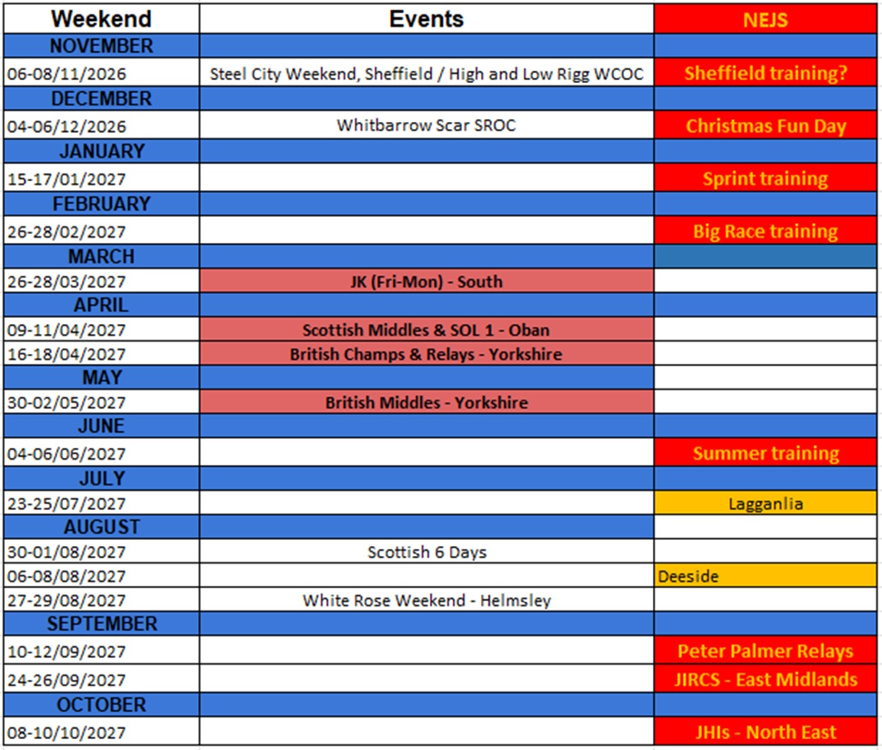
Thank you for your continued support

Scroll down for photos

2025/26 highlights
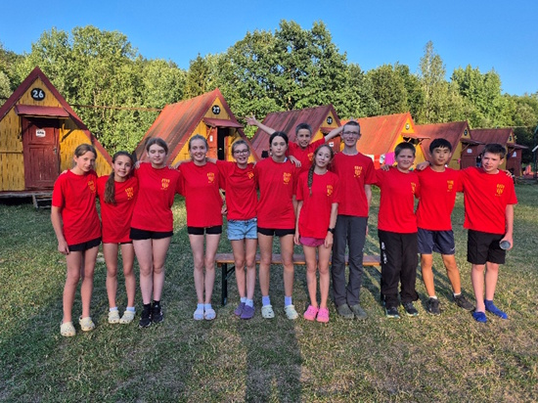 | 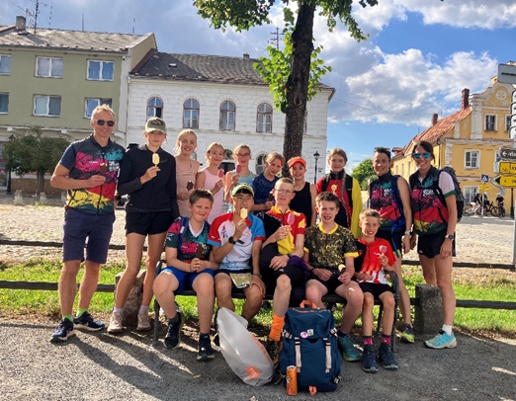
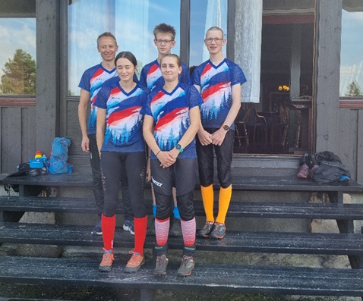 | 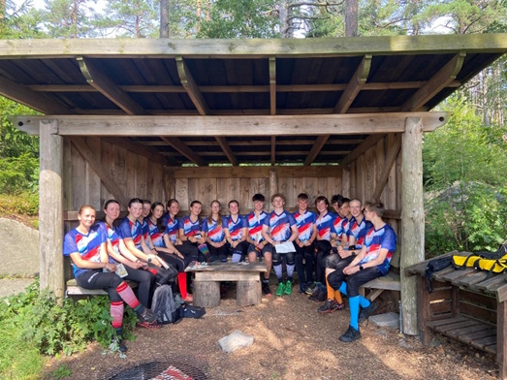
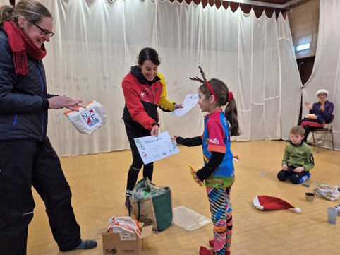 | 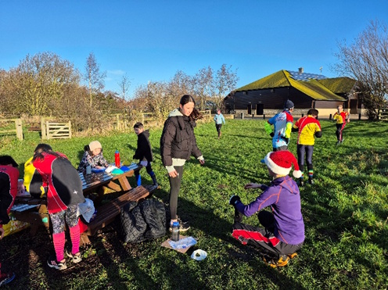
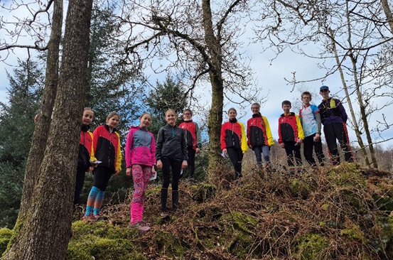 | 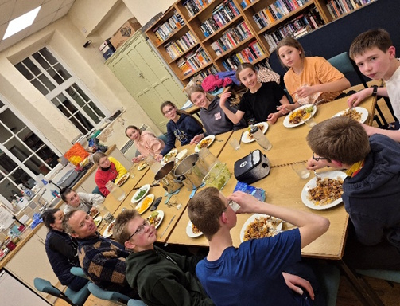
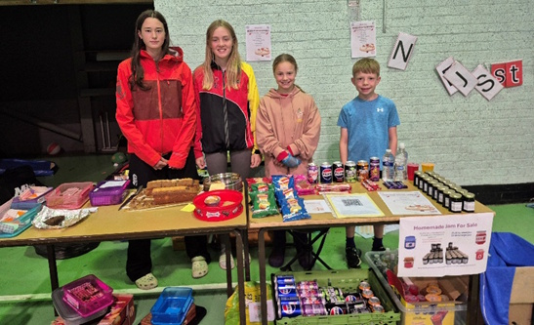 | 